HD 183263

HD 183263 is a 1.17 M☉, G2 IV star1. Based on 108 RV HIRES measurements obtained between 2001 and 2019 and 252 RV Apf measurements obtained between 2013 and 2019, the CL survey reported a GP (HD 183263b) with a period of days, a minimum mass of and an eccentricity of 0.3786 ± 0.004 as well as a LPGP (HD 183263c) with a period of days, a minimum mass of 7.97 ± 0.22 MJup and eccentricity of .

In the present study, in addition to the CL survey’s dataset, 20 RV HARPS measurements obtained between 2005 and 2019 were used. DPASS and MCMC (1000 walkers and 300000 iterations) were used to fit the data. The properties found for planets b and c are close to those reported in the CL survey. The fits are shown in Fig 1, and the corner plot in Fig 2, and the results summarized in Table 1.

Conclusion: The properties found in the CL survey for both planets are confirmed.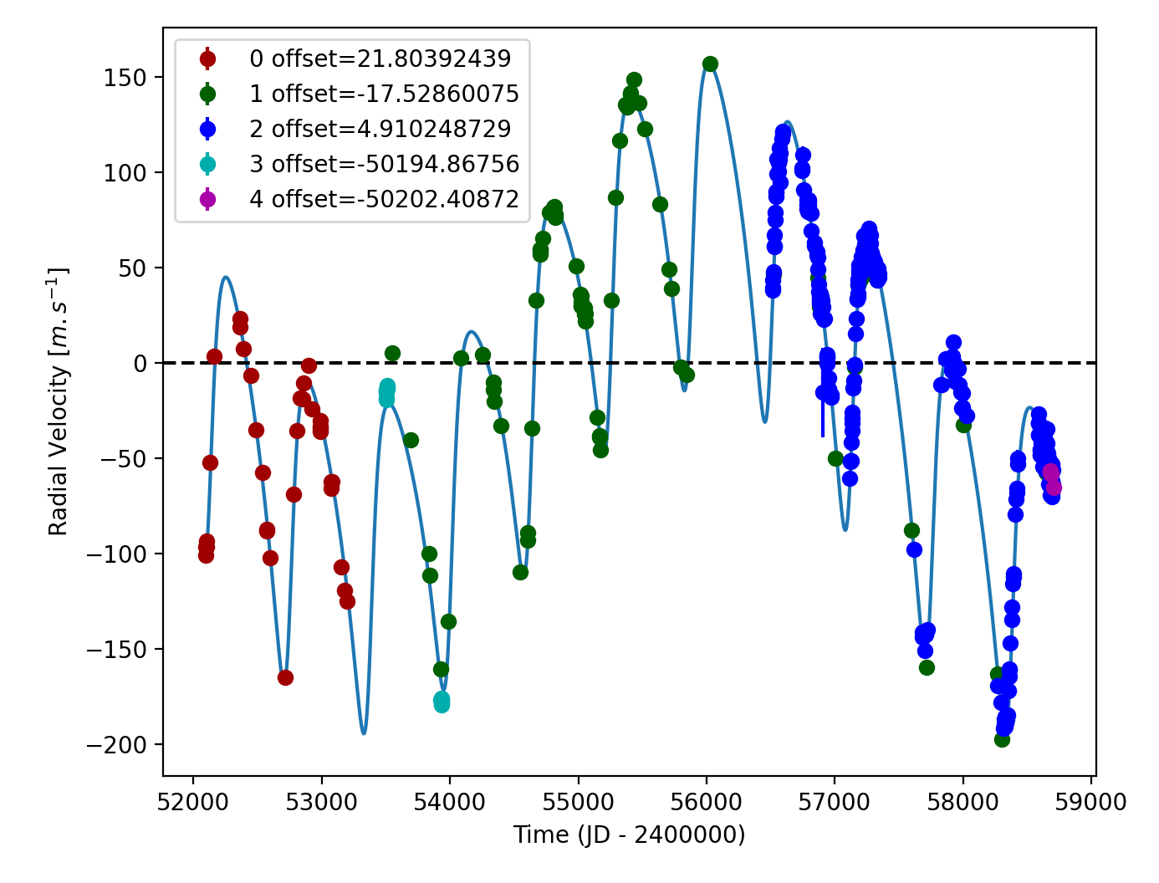

Figure 1: Left: fit of the HD 183263 RV with DPASS. Red - Hir94, green - Hir04, blue - Apf, cyan - H03, purple - H15. The blue curve shows the best fit. Right: fit of the HD 183263 RV using MCMC. The black curve shows the best fit. The colorbar corresponds to the log-likelihood of the fits.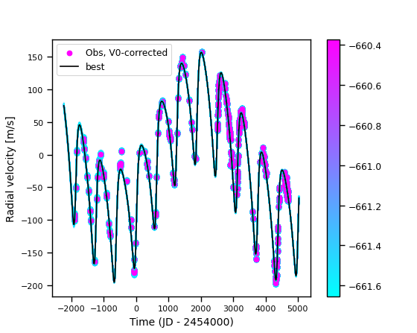

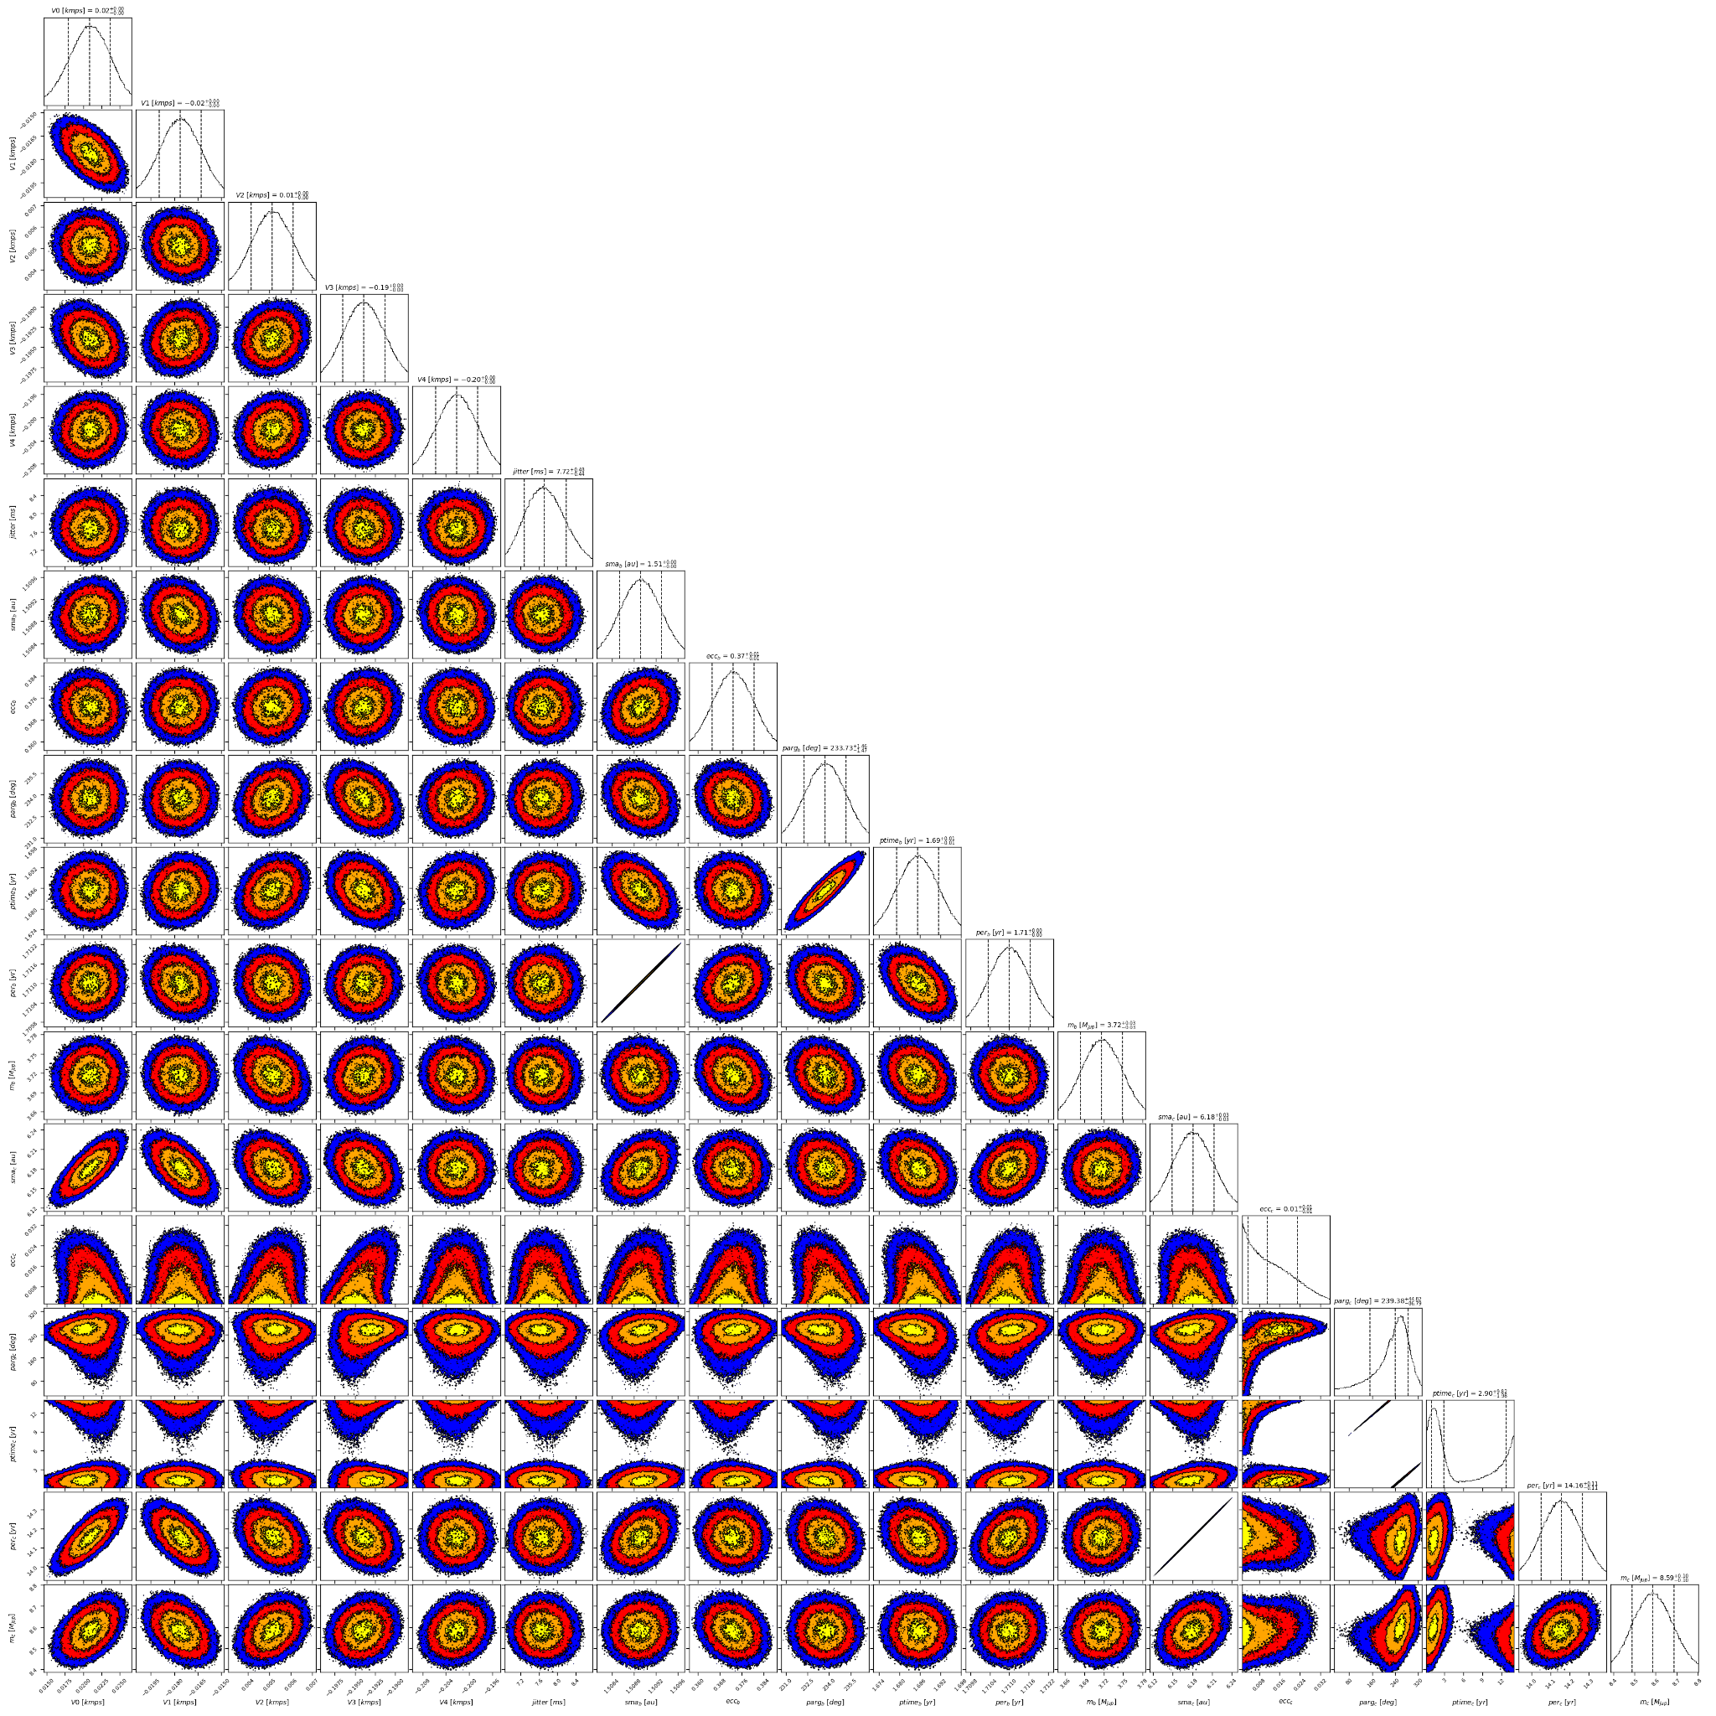

Figure 2: Corner plot of posteriors for the two-planets model MCMC fit of HD 183263 RV data.

| Parameter | Priors | | Posteriors | | CL survey |
| --- | --- | --- | --- | --- | --- |
|  | DPASS | MCMC | DPASS | MCMC |  |
| *a* (au) | b: [0,100]  c: [0,100] | b: [1,2]  c: [3,10] | b = 1.51  c = 6.2 | b = 1.51 ± 0.01  c = 6.18 ± 0.03 | b = 1.508 ± 0.02  c = |
| Msin(i) (MJup) | b: [0,100]  c: [0,100] | b: [0.1,10]  c: [1,20] | b = 3.7  c = 8.6 | b =  c = 8.6 ± 0.1 | b =  c = 7.97 ± 0.22 |
| Eccentricity | b: [0,0.95]  c: [0,0.95] | b: [0,0.95]  c: [0,0.95] | b = 0.37  c = 0.0 | b = 0.37 ± 0.01  c < 0.02 | b = 0.3786 ± 0.004  c = |
| Instrumentals offsets (km/s) | [-60,60] | Hir94: [-1,-1]  Hir04: [-1,-1]  Apf: [-1,-1]  H03: [-51,-49]  H15: [-51,-49] | Hir94: 0.022  Hir04: -0.018  Apf: 0.005  H03: -50.195  H15: -50.202 | Hir94: 0.021 ± 0.003  Hir04: -0.018 ± 0.001  Apf: 0.005 ± 0.001  H03: -50.194 ± 0.003  H15: -50.202± 0.004 |  |
| Stellar jitter (m/s) | [0,40] | [0,20] | 7.4 |  |  |
| Argument of periastron (°) | b: [0,360]  c: [0,360] | b: [0,360]  c: [0,360] | b = 234  c = 176 | b =  c = |  |
| Phase | b: [0,1]  c: [0,1] | b: [0,1]  c: [0,1] | b = 0.4  c = 0.31 | b = 0.98 ± 0.01  c = 0.07 – 0.90 |  |

Table 1: HD 183263. Summary of priors and posteriors obtained with DPASS and MCMC, compared to the properties reported by the CL Survey.

References

1. Marcy, G. Five New Extrasolar Planets. *Astrophys. J.* 619, 570-584 (2005).